Search Widget for Android
TeleNav GPS Navigator 5.2
Functional Specification Document

Version 1.0

Revision History
Date | Version | Description | Author
07/06/2011 | 0.1 | Initial Draft | XinRong Liu
07/12/2011 | 0.2 | - Update the widget size  - remove DSR feature  - Build search widget apk per program to better locate the TN  - add the set home/office ui flow/vdd into dependency  - the behavior of the configuration  - update the topic of the upgrade path | XinRong Liu
07/13/2011 | 0.7 | - Finalize the upgrade path  - Add “click on category” action  - Remove DSR feature totally  - Update the shard DB section  - Update the dependency section | XinRong Liu
07/13/2011 | 0.8 | - Api key per program  - Use Bing map as default | XinRong Liu
07/15/2011 | 0.9 | - Change App Structure section to resources section | XinRong Liu
09/07/2011 | 1.0 | - Update the GPS logic  - Update the resources section, explain why we need use the native image management solution due to technical limitation. | XinRong Liu

Table of Contents
1 Introduction 4
1.1 Purpose 4
1.2 Scope 4
2 Functional requirement 4
3 Design and Implementation 4
3.1 Overview 4
3.2 Interaction 5
3.2.1 Act with server 5
3.2.2 Act with TN 6
3.2 The way to get TN 7
3.3 Upgrade path 7
3.4 Package name 8
3.5 Refresh period 9
3.6 GPS 9
3.7 Shared DB 10
3.8 UI 11
3.9 Resources 11
3.10 Dependencies 11
3.10.1 VDD 11
3.10.2 MaiTai 12

Functional Specification Document

Introduction
The document describes the design implementation of the search widget for Android platform from the developer perspective. Search widget is the widget to help user quickly launch TeleNav through MaiTai interface. And it’s the useful tool to introduce the TeleNav GPS Navigator (aka TN) if the search widget preloaded in the device but TN not.

Purpose
We bring more rich features into search widget compared to the previous one we have in TN 6.2. This document will focus on the technical design and implementation, plus the limitation in android platform which affects the design of the search widget.

Scope
N/A

Functional requirement

Design and Implementation

Overview
Search widget provides three type of the UI layout when put into Home Screen.
FULL PAGE | HALF PAGE | MINI
- Onebox search link w/DSR  - Command bar  - Large Map view  - Home/Work smart buttons | - Onebox search link w/DSR  - Command bar  - Small Map view  - Half size home/work smart buttons | - Onebox search link w/DSR  - Command bar

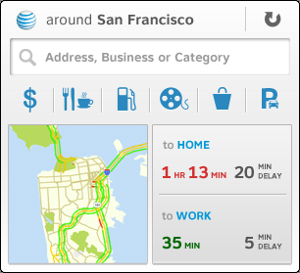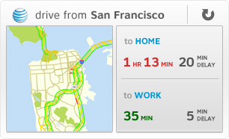
Full Page Half Page Mini Page

In android platform, Home Screen provides 4*4 cell spaces to contain the widgets. Each cell is 74*74 dip, with 2 dip padding. Here is the quickly calculation to get the widget’s size:
Minimum size in dip = (Number of cells * 74dip) - 2dip
The full page size is 4*3 cells which is 294*220 dip.
The half page size is 4*2 cells which is 294*146 dip.
The mini page size is 4*1 cells which is 294*72 dip.

Interaction
The term of Interaction here is to define the actions with server and TN. To simplify it, it separates into two categories:

Act with server
Here are the actions the search widget will talk to server:
- Geocode
- Reverse geocode
- Static map with traffic
- Get ETA
There are two ways to talk to server, one is using the web service provided by TeleNav GeoCloud (http://developer.telenav.com/sdkweb/geocoding?app=geocoding&page=home), and the other is using the c-server like we did in TN products. Here are pros and cons regarding the two ways:
 | Pros | Cons
Talk to web service | - Simple and easy to use.  - Separate with c-server, and not affected by the c-server release train | - Need have the API key to accomplish the request.  - Have the limitation access per API key. May exceed the number in the future.
Talk to C-server | - Can share the code with TN we have | - Need add secret page to change server which provides the convenience to QA/developers to test on different environment  - Some actions may need user id, etc to accomplish the request; otherwise it will throw exception in server side. To get the information such this, it needs login before use the search widget.

As discussed in the meeting, we may use the web service to accomplish the above actions. Here are web service list if client talks to web service:
 | Web service
Geocode | http://api.telenav.com/tnapi/services/geoutil/geocode
Reverse geocode | http://api.telenav.com/tnapi/services/geoutil/reverseGeocode
Static map with traffic | http://api.telenav.com/tnapi/services/map/getMap
Get ETA | http://api.telenav.com/tnapi/services/routing/getETA

Here are some tips regarding the web service support:
- We need apply different API key per program code. This is for the tracking purpose.
- Since search widget is free, it’s ok to use the Bing map by default to show the static map

Act with TN
Here are the actions the search widget will act with TN:
- Drive to Home
- Drive to Office
- One box search
- Click on static map
- Read Home
- Read Office
- Click on category
To act with TN, we have the TN Connection (aka MaiTai) interface to support the 3rd party application calls. This is the way we used in the old search widget. As discussed, we will continue to use the MaiTai interface to act with TN.
MaiTai doesn’t provide the action to support click on category, we need:
- Add new action in Maitai to support the action
- Define the behavior in TN 7.x how it looks when user selects the category in search widget
(See “FSD_MaiTaiConnect2.1_System-Wide_07272011.doc” section 4.3.3 for details).

Here are existed MaiTai URIs supports the below actions:
 | URI
Drive to home/office | telenav://driveTo?v=2.0&c=cn&k=<key>&addr2=<home/office Address>&type=nav
One box search | telenav://search?v=2.0&c=cn&k=<key>&addr=<one box search>
Click on static map | telenav://map?v=2.0&c=cn&k=<key>&namedAddr=CURRENT

The way to get TN
In normal case, search widget is provided as a separate apk and preloaded into device’s firmware. That means when search widget is existed, TN may not be in place in device. It’s the good way the search widget can help user download the TN.
MaiTai library provides a URL to help the 3rd party application get the TN. It’s http://wap.telenav.com/get defined in MaiTai document. However, as I know, the service is not available and the URL is hard coded in MaiTai library.
So is it the way to get TN? Before we define the right way, we need answer below questions:
- Does the URL need server driven? If yes, how?
- How does the search widget know to get the right TN? For example, AT&T Navigator or TeleNav GPS Navigator? What’s the rule?
Per discussion, if TN is not existed, search widget will launch VPL directly and VPL will launch android market then. It happens when:
- User clicks on the poi category icon, map.
- User inputs something in one box search box and clicks ok.

Upgrade path
To extend the life time of the search widget, we’d better provide the upgrade method to upgrade the search widget in the future. Either fixes bugs, add new features, or modify the color scheme, etc. And there is one requirement from PM as well: we need provide the separate search widget apk so OEM can preload it into the firmware.
To satisfy both of them, here is the solution we get:
Search widget will be part of the TN and compile and packaged into one apk with TN. At the same time, we’ll pick up the source code and the resource files of the search widget from TN and compile and package into separate apk which provides to OEM. Here is the upgrade path:

Use this way we can simplify the upgrade effort for search widget. We don’t need take care how to notify the search widget when there is a new version available, and we don’t need take care the OTA drop as well.
Preloaded
Stub app
Search widget
TN one apk
TN
New Search widget
Download

Per discussion, we all agree approaching this way to upgrade the search widget. It needs:
- Build stub app and search widget into one apk
- Build search widget and TN into one apk

Package name
Package name is the unique ID of the android application. The old search widget application has one package name for all of carriers.
According to PM’s feedback, we may have the color scheme requirement for white labeled TN and TeleNav labeled TN. To satisfy the requirement, we have two choices:
Option 1: Keep same package name, provide different apks for different carriers with different resource files
Option 2: Use different package name for different carriers with different resource files.
Here are the pros and cons regarding the two options:
 | Pros | Cons
Option 1 | - Can overwrite the old search widget with same package name  - Flexible to support different color schemes  - Don’t need take care how to define the package name for different carriers | - N/A
Option 2 | - If we have the requirement to keep different search widgets in one device, then we have to choose this option | - If there is old search widget installed in the device, when you download the new one, you will see both of them in the device.

Refer to the section “the way to get TN”, We need use the option 2.
This doesn’t need us do any particular thing for the package name because search widget shares the same package name with TN and TN is already provided per program code.

Refresh period
There are three situations will trigger the map and current location update:
- When the search widget put into Home Screen
Overwrite the AppWidgetProvider.onUpdate() to refresh map
- When the screen backlight off and on
Use below code to register the backlight on and off broadcast event to get the notification:
IntentFilter filter = new IntentFilter(Intent.ACTION_SCREEN_ON);
filter.addAction(Intent.ACTION_SCREEN_OFF);
screenStateReceiver = new ScreenStateReceiver();
registerReceiver(screenStateReceiver, filter);
- When browse to the search widget page in the Home Screen
This method is not implemented because we don’t find the way to receive the event

GPS
Search widget only uses the GPS (Including network based and satellite based) to get user’s current location and show the map. We don’t need update the user’s location periodically. Once search widget gets the GPS location, it stops the GPS acquiring immediately. (See Refresh period).
Here is the logic to get one GPS shot:

Read GPS from widget DB
Read GPS from TN DB
Exist?
Exist?

Read GPS from getLastKnownLocation
Exist?

N
Y
N
N
Y
Y
Is GPS in 60 sec?
Y
Start GPS reader
Is GPS read success?
Store GPS to widget DB
Widget DB
Stop GPS reader
Y
Read Success
N

N

Shared DB
Shared DB is the words to describe the mechanism to share the data between applications. Search widget will read the home and office address from TN.
Since search widget combines to the TN into one apk which means they’re the same application, they can read the DB each other. There is no more mechanism we need to do any more.
We have two types of DB shared between TN and widget:
- Home and work address
TN and widget will read and write on both sides.
- GPS
Widget will read the TN’s GPS but not write, TN won’t read or write any widget’s GPS DB

UI
Refer to the section “Overview”, the search widget size is per dip (density-independent pixel), the current UI implementation in TN 7.x doesn’t support it. To shorten the develop time, we need use the native UI layout directly.

Resources
We shall need use the same mechanism in TN 7.0 to handle the images and strings. That brings us the benefit to download and replace the old ones in search widget.
However, for the images, the real world is that we use the android’s native way to handle it. The reasons are:
- Call RemoteViews.setImageViewBitmap() is an expensive method
If we handle the images by ourselves like TN did, we may need create bitmap and pass the object to the widget by calling setImageViewBitmap(). However, this function is very expensive, because:
Widget and the widget container (or Host) is in different process, the data transferred between them are by IPC (Inter-Process Communication), the data size has limitation. For example, in android platform, if you transfer the data over 100K, the system will throw “binder error” exception and you can’t transfer any data any more.
- Call RemoteViews.setImageViewUri() needs put the images into public storage
Or we can use setImageViewUri() to reduce the data transfer size between widget and the widget container. However, as explained above, widget and the widget container is in different process and don’t have the same signature, due to security limitation, if you pass the image’s Uri from widget to widget container, the image has to put into public storage. That means the images (wherever you store them into apk or download from server) should put into SD card. SD card is not a safe and reasonable place, user can remove the SD card, or mount the SD card by other applications. In those situations, the SD card is not available and the images stored in this place are not available too.
- 9-patch limitation.
In the widget, we used the native 9 patch images solution to draw the background to reduce the package size. However, to use it, you have to use resource management rather than assets management. Assets management can’t generate 9-patch information from the raw image data. Since the 9-patch information generation is not public, at this time, we have no idea how to generate it by ourselves.

Due to the technical limitation above, we have to use the native image management rather than the one we have in TN 7.x. And use this way, we can’t support the image update through c-server except the strings.

Dependencies

VDD
It includes below designs:
- Search widget full page/half page/mini page

- The look and feel of the search widget item in the widgets list, for example, below are the old search widget item (Need define the string, icon for different carriers):
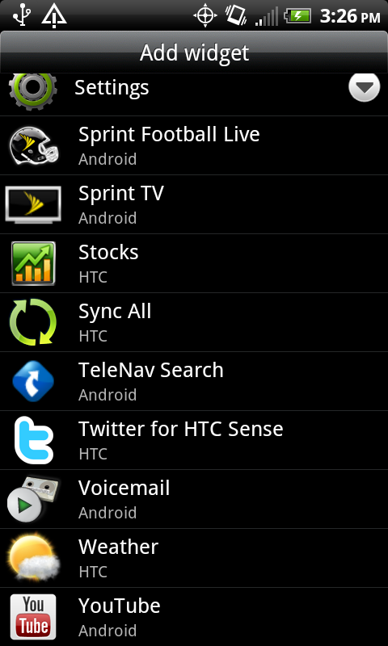

- Configuration to let user select page size
Per PM, we just need show the popup to let user select one of the pages. However, we still need define the string in popup.

- Set home/office
The UI and flow to set home/office address in search widget.

MaiTai
- Add new action to support click on category

- Define the behavior in TN 7.x when user click on category in search widget

- Add the program code support to download URL and make the service available

